Set 18: Product Inventory Management
Dataset: Product Inventory
Product ID Product Name Quantity Available Price (in $)
1 Product A 250 20
2 Product B 175 15
3 Product C 300 18
1. Create a bar chart to visualize the quantity of each product in the inventory. Label the axes and title the chart.
library(ggplot2)

inventory <- data.frame(
Product_ID = c(1, 2, 3),
Product_Name = c("Product A", "Product B", "Product C"),
Category = c("Category 1", "Category 2", "Category 1"),
Quantity_Available = c(250, 175, 300),
Price = c(20, 15, 18)
)

View(inventory)

# Bar Chart
ggplot(inventory,
aes(x = Product_Name,
y = Quantity_Available,
fill = Product_Name)) +
geom_bar(stat = "identity") +
labs(
title = "Product Inventory Quantity",
x = "Product Name",
y = "Quantity Available"
) +
theme_minimal()
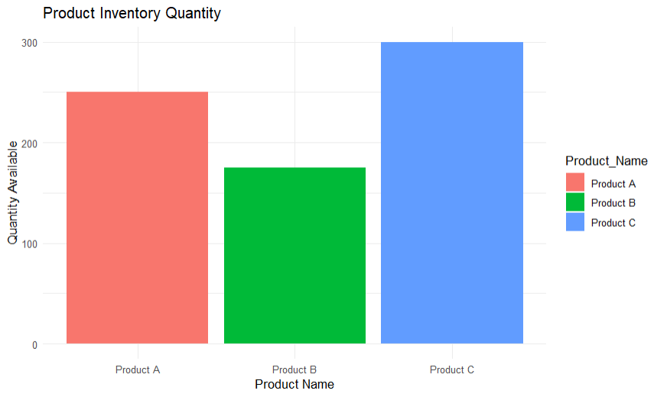
2. Generate a stacked bar chart to show the quantity of each product within different product categories.
# Stacked Bar Chart
ggplot(inventory,
aes(x = Category,
y = Quantity_Available,
fill = Product_Name)) +
geom_bar(stat = "identity") +
labs(
title = "Inventory by Product Category",
x = "Category",
y = "Quantity Available"
) +
theme_minimal()
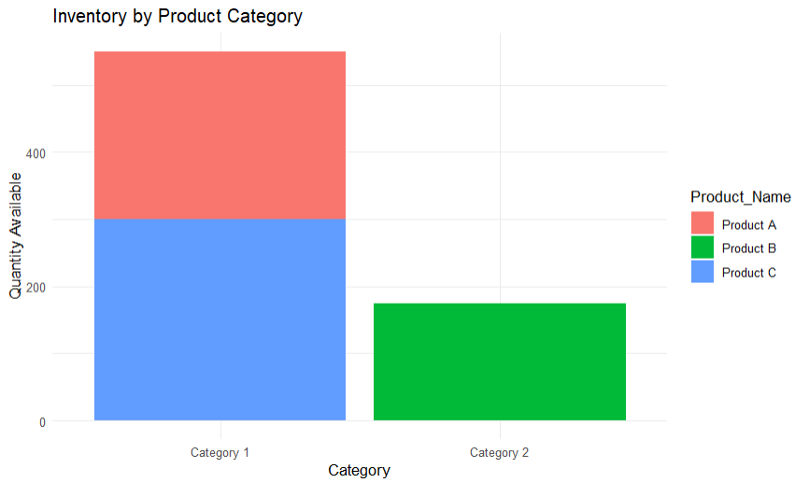
3. Build a table to show the inventory data for each product. Label the table elements.
View(inventory)
# OR
print(inventory)
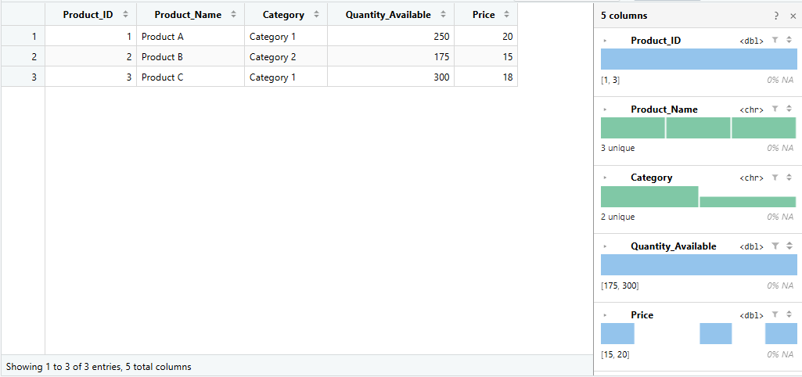

Set 19: Survey Responses Analysis
Dataset: Survey Responses
Survey ID Question 1 Question 2 Question 3
1 A B C
2 B A D
3 C A B
1. Create a grouped bar chart to visualize the distribution of answers for Question 1. Label the chart elements.
library(ggplot2)
library(reshape2)
survey <- data.frame(
Survey_ID = c(1,2,3),
Question1 = c("A","B","C"),
Question2 = c("B","A","A"),
Question3 = c("C","D","B")
)
View(survey)
# Grouped Bar Chart
q1 <- as.data.frame(table(survey$Question1))
colnames(q1) <- c("Answer","Count")
ggplot(q1,
aes(x = Answer,
y = Count,
fill = Answer)) +
geom_bar(stat = "identity",
position = "dodge") +
labs(
title = "Distribution of Answers for Question 1",
x = "Answers",
y = "Number of Responses"
) +
theme_minimal()
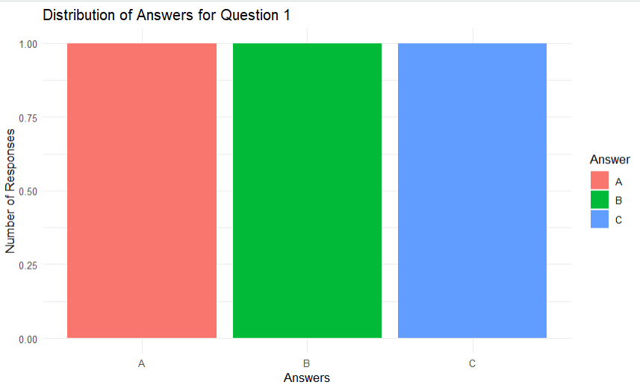
2. Generate a stacked bar chart to represent the overall distribution of responses for all three questions.
# Stacked Bar Chart
long <- melt(
survey,
id.vars = "Survey_ID",
variable.name = "Question",
value.name = "Answer"
)
ggplot(long,
aes(x = Question,
fill = Answer)) +
geom_bar() +
labs(
title = "Overall Distribution of Survey Responses",
x = "Questions",
y = "Number of Responses"
) +
theme_minimal()
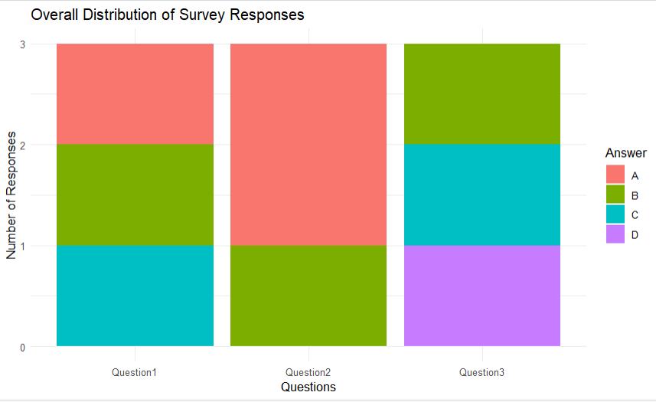
3. Build a table to show the survey response data for each survey. Label the table elements.
View(survey)
# OR
print(survey)
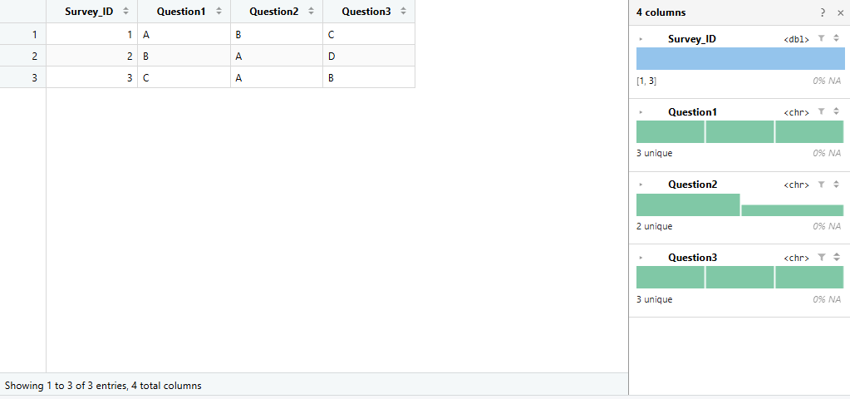
Set 20: Stock Analysis
Dataset: Stock Prices
Date Stock A Stock B Stock C

2023-01-01 100 150 120
2023-01-02 105 152 118
2023-01-03 110 148 122
1. Create a line chart to visualize the stock prices of three companies (Stock A, Stock B, and Stock
C) over a specific time period. Label the axes and title the chart.
library(ggplot2)
library(reshape2)

stock <- data.frame(
Date = as.Date(c("2023-01-01",
"2023-01-02",
"2023-01-03")),
Stock_A = c(100,105,110),
Stock_B = c(150,152,148),
Stock_C = c(120,118,122)
)

View(stock)

# Convert to long format
stock_long <- melt(
stock,
id.vars = "Date",
variable.name = "Company",
value.name = "Price"
)

# Line Chart
ggplot(stock_long,
aes(x = Date,
y = Price,
color = Company,
group = Company)) +
geom_line(linewidth = 1) +
geom_point(size = 3) +
labs(
title = "Stock Prices of Three Companies",
x = "Date",
y = "Stock Price"
) +
theme_minimal()
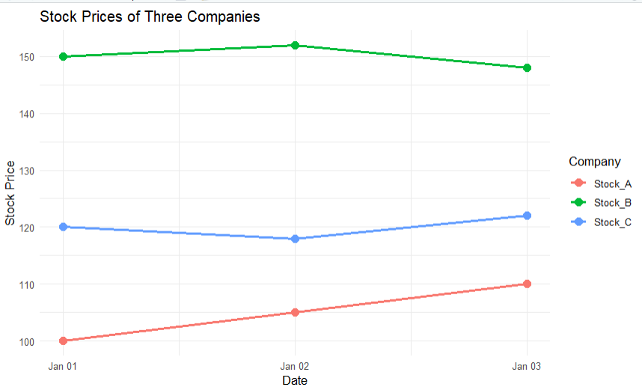
2. Generate a bar chart showing the daily percentage change in stock prices for Stock A. Label the chart elements.
# Percentage Change
stock$Percent_Change <- c(
0,
(stock$Stock_A[2]-stock$Stock_A[1])/stock$Stock_A[1]*100,
(stock$Stock_A[3]-stock$Stock_A[2])/stock$Stock_A[2]*100
)
# Bar Chart
ggplot(stock,
aes(x = Date,
y = Percent_Change)) +
geom_bar(
stat = "identity",
fill = "steelblue"
) +
labs(
title = "Daily Percentage Change of Stock A",
x = "Date",
y = "Percentage Change (%)"
) +
theme_minimal()
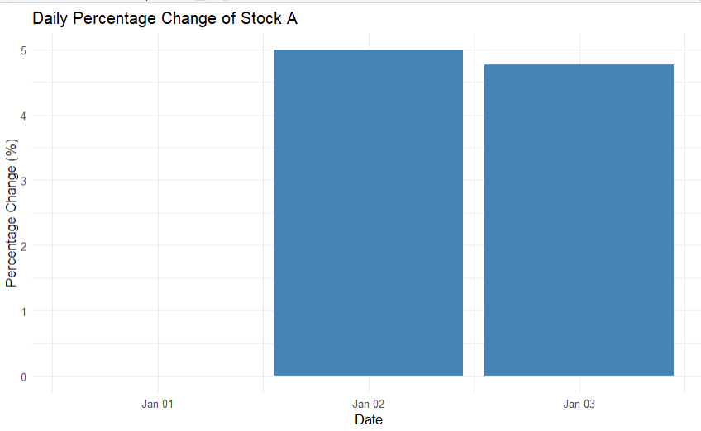
3. Build a table to display the stock price data for each company over the given period. Label the table elements.
View(stock)
# OR
print(stock)
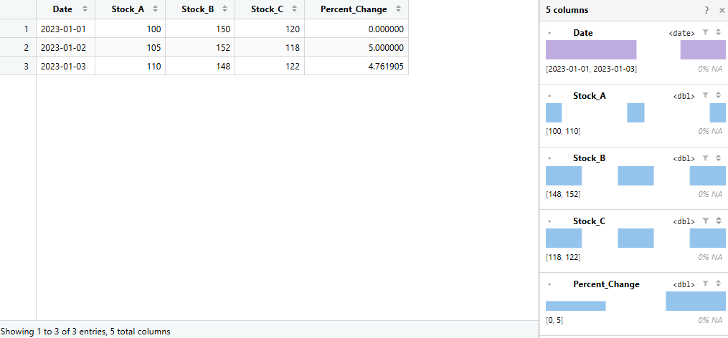
Set 21

Dataset: Energy_Consumption_Data.csv

Sector Region Month Temperature
(°C)
Units_Consumed
(kWh)

Cost
(₹)
Renewable_Usage
(%) Peak_Hours
Residential North Jan 15 320 2100 22 4
Commercial South Jan 24 540 3600 18 6
Industrial West Feb 20 880 5900 12 8
Residential East Feb 18 350 2300 25 5
Commercial North Mar 28 610 4100 20 7
Industrial South Mar 30 920 6200 15 9
1. Import the dataset in R. Plot a histogram and density plot for Units_Consumed. Compare consumption patterns.
library(ggplot2)

energy <- data.frame(
Sector = c("Residential","Commercial","Industrial",
"Residential","Commercial","Industrial"),
Region = c("North","South","West",
"East","North","South"),
Month = c("Jan","Jan","Feb","Feb","Mar","Mar"),
Temperature = c(15,24,20,18,28,30),
Units_Consumed = c(320,540,880,350,610,920),
Cost = c(2100,3600,5900,2300,4100,6200),
Renewable_Usage = c(22,18,12,25,20,15),
Peak_Hours = c(4,6,8,5,7,9)
)

View(energy)

# Histogram
ggplot(energy, aes(x = Units_Consumed)) +
geom_histogram(binwidth = 100,
fill = "skyblue",
color = "black") +
labs(title = "Histogram of Units Consumed",
x = "Units Consumed (kWh)",
y = "Frequency") +
theme_minimal()

# Density Plot
ggplot(energy, aes(x = Units_Consumed)) +
geom_density(fill = "lightgreen",
alpha = 0.5) +
labs(title = "Density Plot of Units Consumed",
x = "Units Consumed (kWh)",
y = "Density") +
theme_minimal()
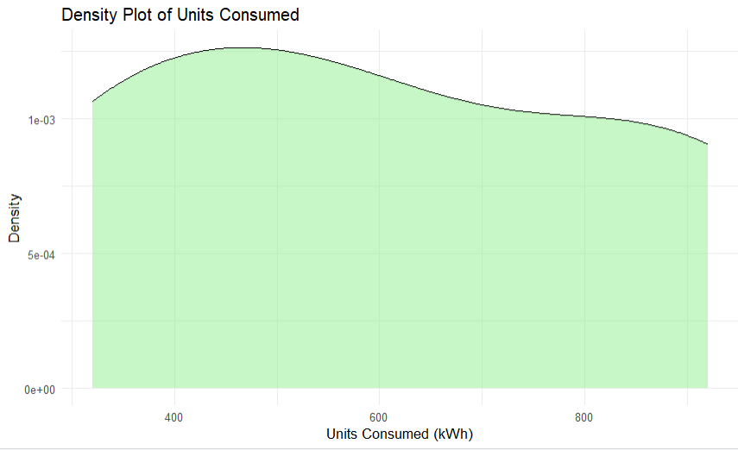
2. Using R programming, create a scatter plot between Temperature and Units_Consumed. Represent Peak_Hours using bubble size. Apply transparency.

# Bubble Scatter Plot
ggplot(energy,
aes(x = Temperature,
y = Units_Consumed,
size = Peak_Hours)) +
geom_point(color = "blue",
alpha = 0.6) +
labs(title = "Temperature vs Units Consumed",
x = "Temperature (°C)",
y = "Units Consumed (kWh)") +
theme_minimal()
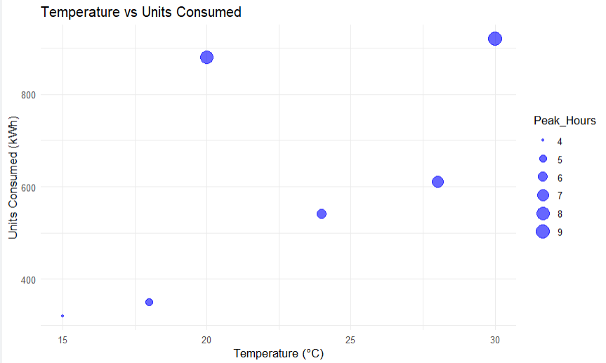
3. Using R, calculate average Renewable_Usage for each Sector. Create a bar chart. Interpret renewable energy adoption.

# Average Renewable Usage
avg_usage <- aggregate(
Renewable_Usage ~ Sector,
data = energy,
mean
)

# Bar Chart
ggplot(avg_usage,
aes(x = Sector,
y = Renewable_Usage,
fill = Sector)) +
geom_bar(stat = "identity") +
labs(title = "Average Renewable Energy Usage",
x = "Sector",
y = "Renewable Usage (%)") +
theme_minimal()
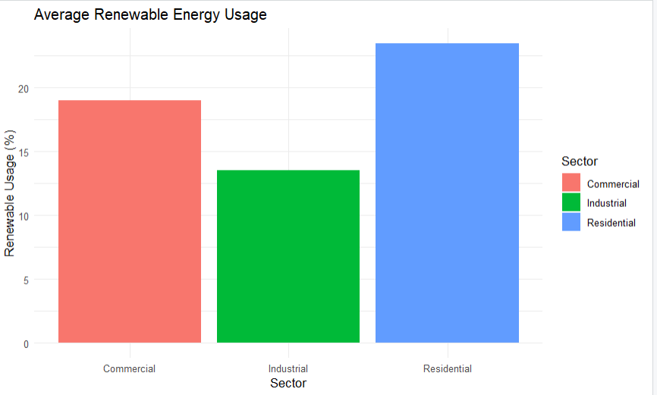
Set 22: Time Series Analysis
Dataset: Monthly Sales Data
Month Sales (in $)
January 15000
February 18000
March 22000
April 20000

May 23000
1. In R, create a time series line chart to visualize the trend in monthly sales. Label the axes and title the chart.
library(ggplot2)

sales <- data.frame(
Month = factor(c("January", "February", "March", "April", "May"),
levels = c("January", "February", "March", "April", "May")),
Sales = c(15000, 18000, 22000, 20000, 23000),
Advertising_Budget = c(2000, 2500, 3000, 2800, 3200),
Product = c("Product A", "Product B", "Product A", "Product C", "Product B")
)

View(sales)

# Line Chart
ggplot(sales,
aes(x = Month,
y = Sales,
group = 1)) +
geom_line(color = "blue", linewidth = 1) +
geom_point(color = "red", size = 3) +
labs(title = "Monthly Sales Trend",
x = "Month",
y = "Sales ($)") +
theme_minimal()
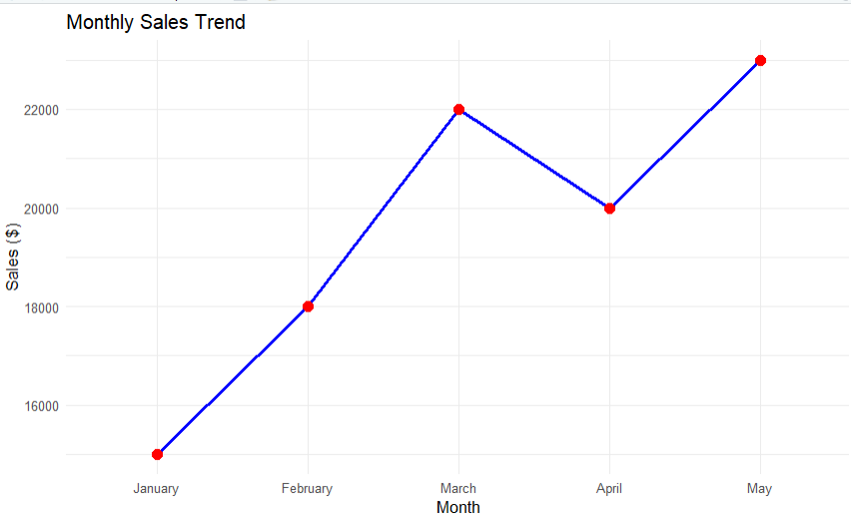
2. In R, generate a scatter plot to analyze the relationship between advertising budget and monthly sales. Explain any insights.

# Scatter Plot
ggplot(sales,
aes(x = Advertising_Budget,
y = Sales)) +
geom_point(size = 4,
color = "blue") +
geom_smooth(method = "lm",
se = FALSE,
color = "red") +
labs(title = "Advertising Budget vs Monthly Sales",
x = "Advertising Budget ($)",
y = "Sales ($)") +
theme_minimal()
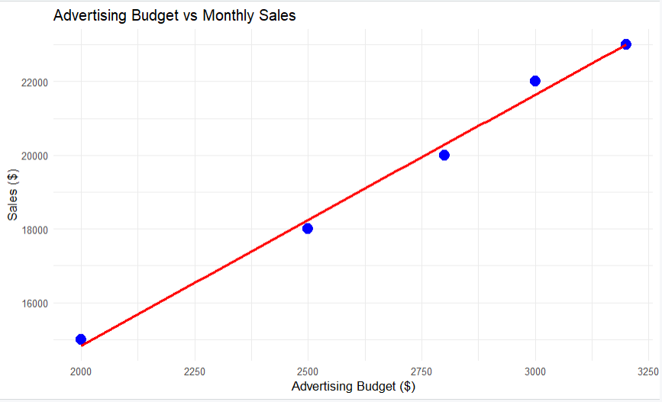
4. In R, create an autocorrelation plot to identify seasonality in the time series data.
# Autocorrelation Plot
sales_ts <- ts(sales$Sales, frequency = 12)
acf(sales_ts,
main = "Autocorrelation Plot of Monthly Sales")
